GOODRICH HIGH SCHOOL
BOYS VARSITY SOCCER
Boys Varsity Soccer ties Fenton 0 - 0
Wednesday, October 4, 2023
6:30 PM
Goodrich High School |  | Fenton High School

HOME | AWAY
0 | 0

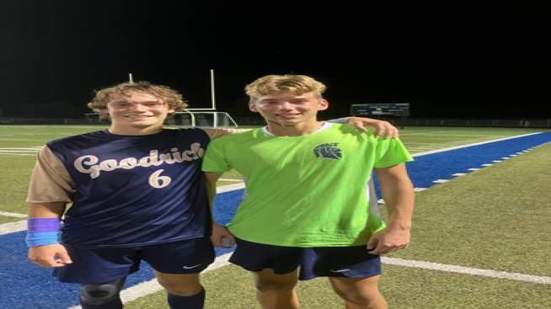
A back and forth game at home with Fenton to round out the FML schedule, ends in a 0-0 tie. Players of the Game GK Kyle Elges and Peyton Mullane for their outstanding efforts throughout the contest! Undefeated Homecoming Week!

