GOODRICH HIGH SCHOOL
BOYS VARSITY SOCCER
Boys Varsity Soccer beats Owosso 2 - 0
Monday, October 2, 2023
6:30 PM
Goodrich High School |  | Owosso High School

AWAY | HOME
2 | 0

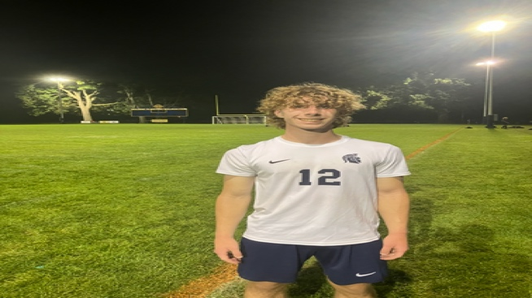
Cody Tiedeman is the player of the Game at Owosso for the strong play throughout the contest! John Pringle and Parker Jerome with goals on the night. Ben Ashley with 2 assists!

Great start to Homecoming Week!!! @AdGoodrich @MartianMadness

