KEARSLEY HIGH SCHOOL
GIRLS VARSITY BOWLING
Kearsley High School Girls Varsity Bowling beat Owosso High School 25-5
Monday, December 4, 2017
5:30 PM
Kearsley High School |  | Owosso High School

AWAY | HOME
25 | 5

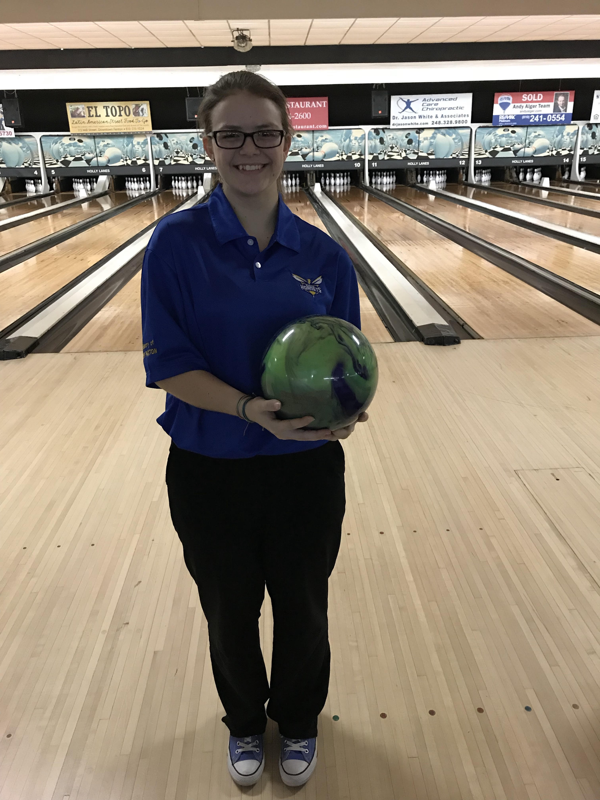
The Kearsley Varsity Girls traveled to Holly Lanes for a Metro Conference match with Owosso, the first time that Kearsley has bowled against Owosso in at least 8 years in a conference match. The varsity girls started the match with Baker games of 182 & 175 to Owosso's 123 and 147 and the Hornets took a 10-0 lead into the individual games. In the first individual game the Hornets won 3 individual points and the game for a 17-3 lead heading into the final game. The final game saw the Hornets win 2 individual points and the game and they won the match by a final score of 25-5. Leading the Hornets was Sophomore Samantha Timm who had games of 190 and 235. The win marks the 90th straight Metro Conference win for the Varsity girls, a winning streak that has stretched into it's 9th year. The lady Hornets are now 2-0 on the season with the next match on Saturday, December 10th at Cherry Hill Lanes in Clarkston against Holly.

