KEARSLEY HIGH SCHOOL
GIRLS VARSITY BOWLING
Kearsley High School Girls Varsity Bowling finishes 1st place at Regionals- Team @ Monitor Lanes
Friday, February 23, 2018
8:00 AM
Place |  | Points

1 | 0

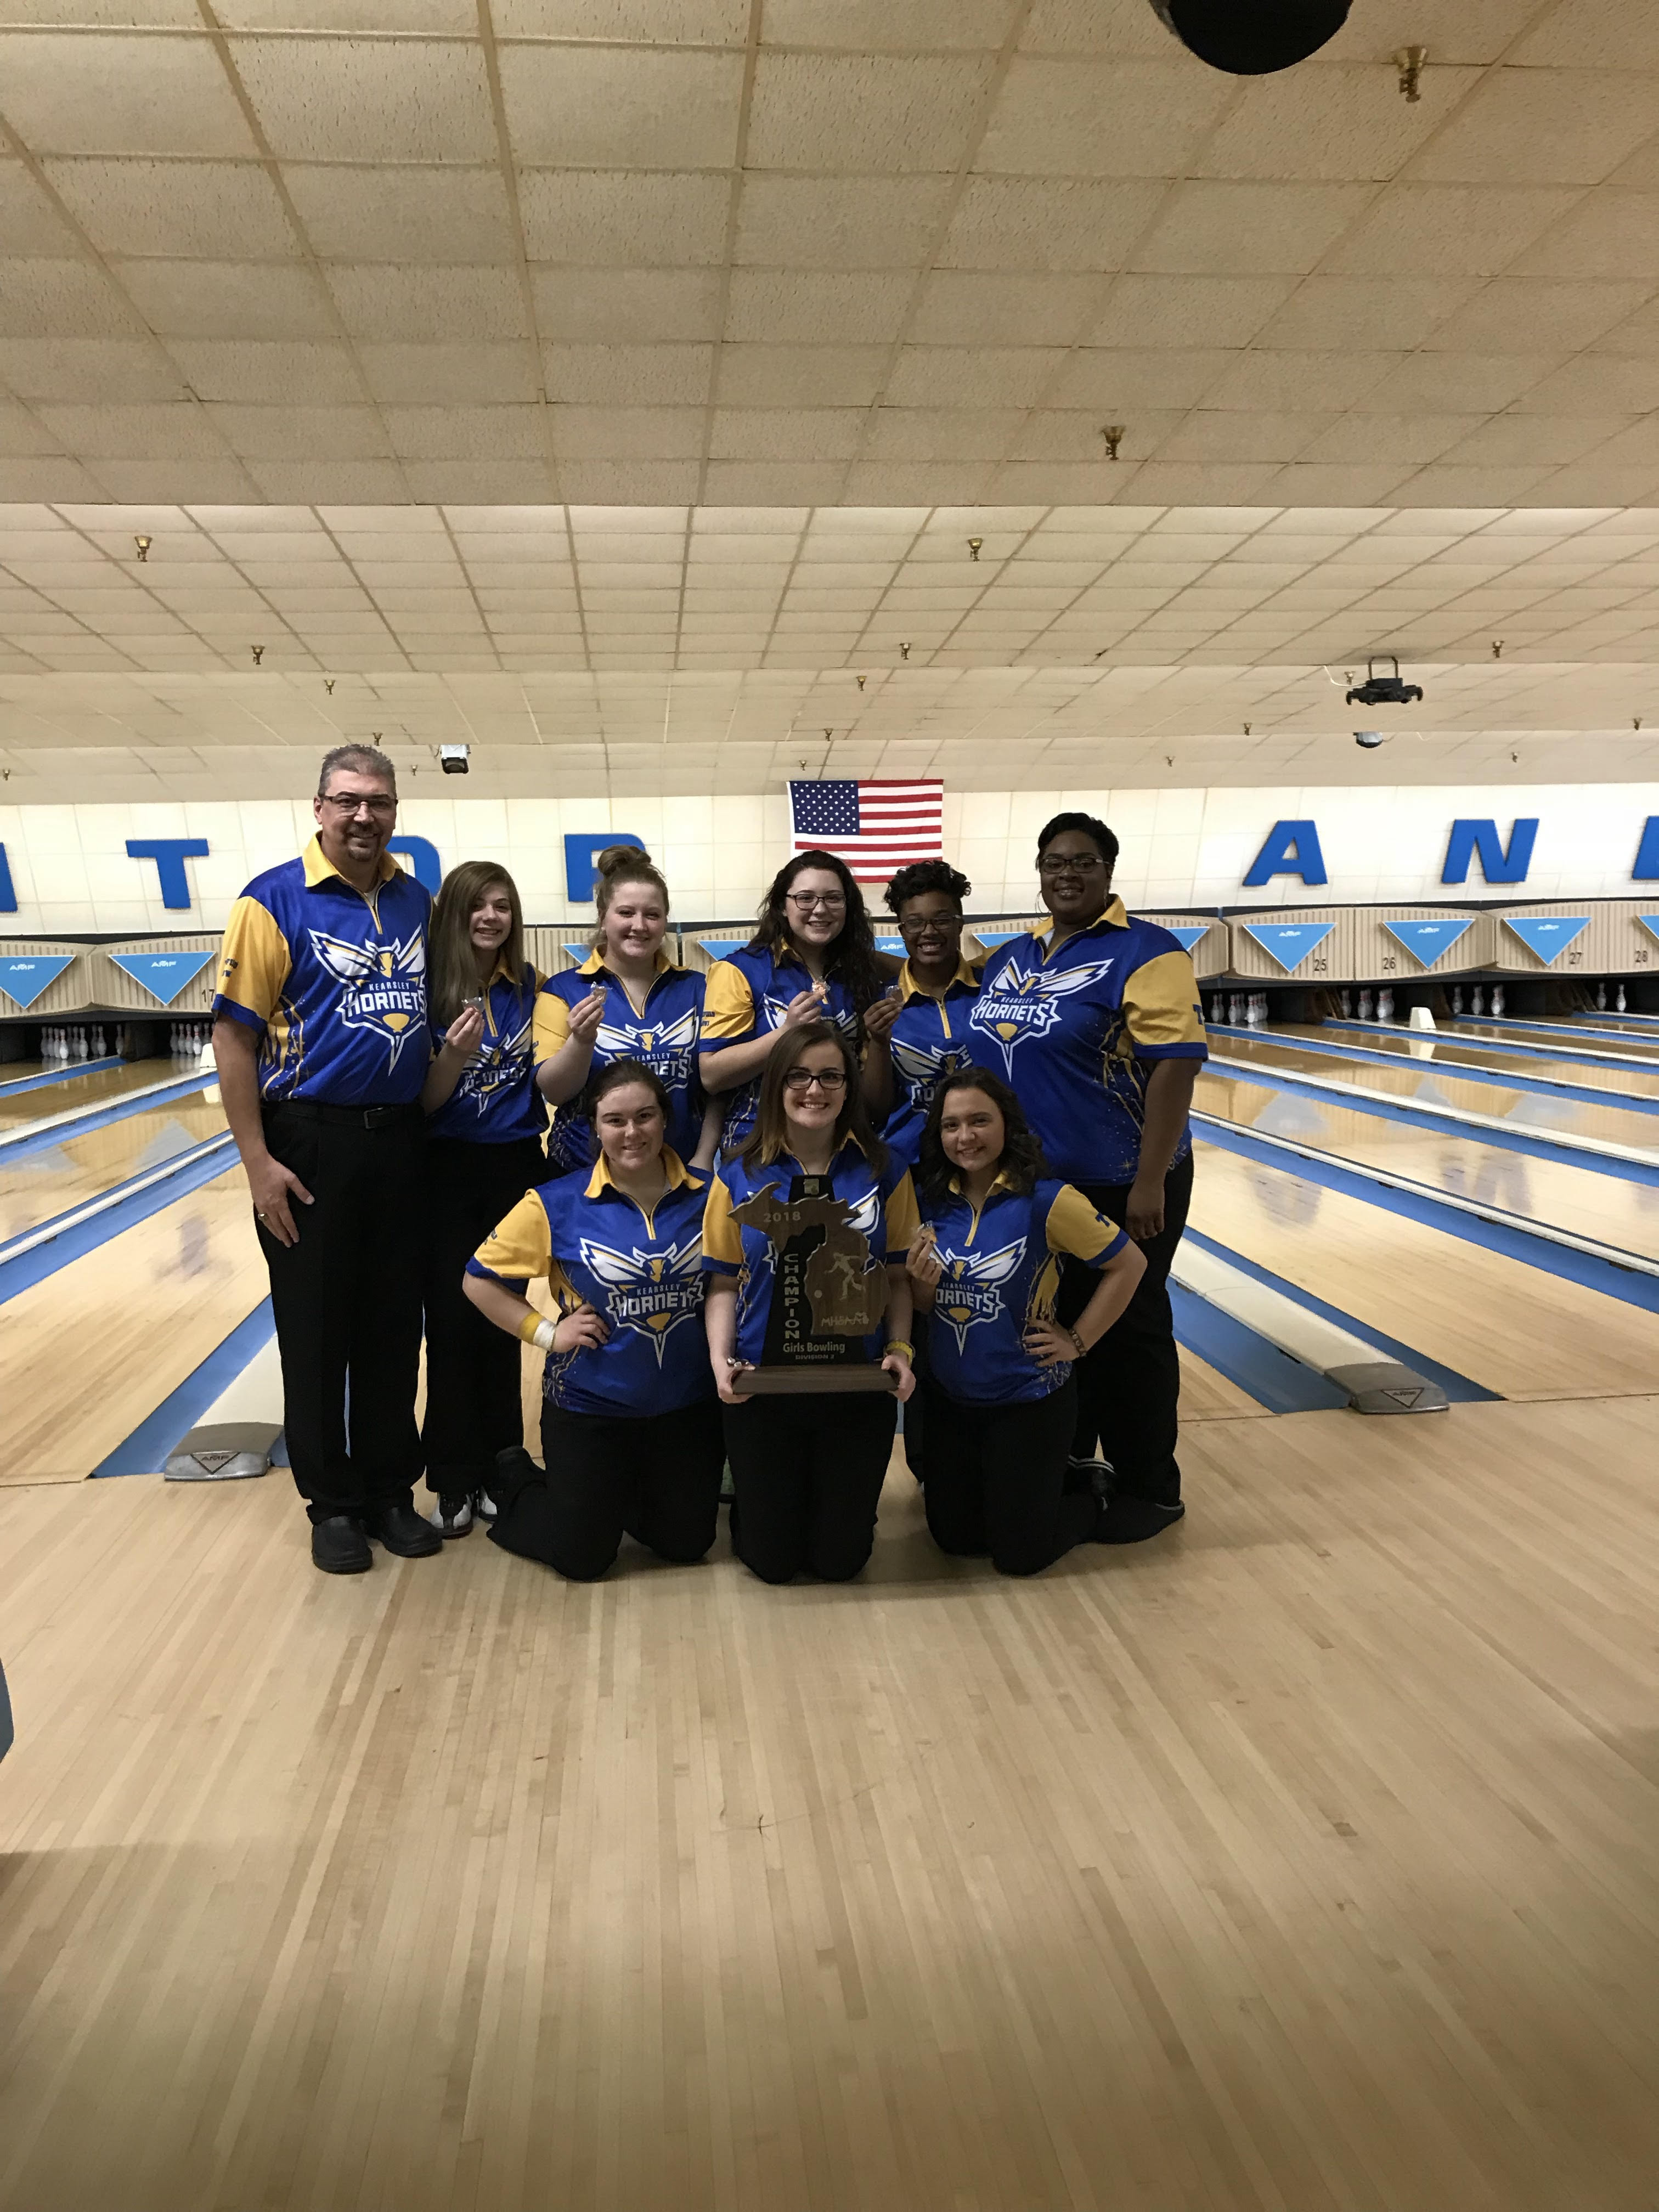
The Kearsley Varsity girls traveled to Bay City for the Regional Team Event at Monitor Lanes on Friday, February 23rd. The Kearsley girls entered Regionals as the #1 ranked team in the state and they showed why. They began the day with Baker games of 210 and 169 to take an early lead and then never looked back as they had Baker games of 173, 192, 169 and 168. They had 1081 after the 6 Baker games and took a 90 pin advantage into the individual part of Regionals. The first team game the Kearsley girls had a 901 team game, the highest in the Region for girls teams and then followed that up with games of 892 and 909 to finish with a total of 3783 and a first place finish. Finishing 2nd was Croswell Lexington with a total of 3466 and finishing 3rd was Escanaba with a total of 3443. High scores for the girls were Emma Boychuk with games of 193 & 226, Alexis Roof with games of 203 & 200, Imari Blond with a 203 game and Barbara Hawes with games of 188 & 180.
The Kearsley girls score of 3783 was the highest girls score in the state of Michigan for Regionals for all divisions. The Lady Hornets are now one of 18 teams remaining and will bowl in the State Finals on Friday, March 2nd at The Super Bowl in Canton, Michigan.
School |  | Place |  | Points

Kearsley High School |  | 1 |  | 0

Croswell-Lexington High School |  | 2 |  | 0

Escanaba High School |  | 3 |  | 0

