OWOSSO HIGH SCHOOL
GIRLS VARSITY SWIMMING
Owosso High School Girls Varsity Swimming beat Brandon High School 113-67
Thursday, October 12, 2017
6:00 PM
Owosso High School |  | Brandon High School

HOME | AWAY
113 | 67

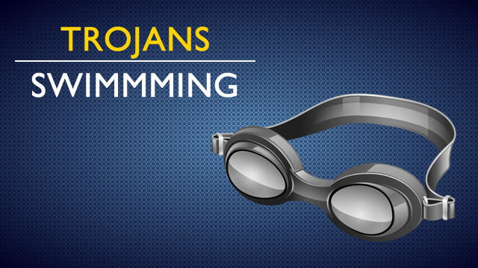
First place finishes went to:
Medley relay Owosso Chamberlin, Espinoza, Voss, Clevenger 2:12.16
200 free Brandon Whitkopf 2:03.39
IM Owosso Espinoza 2:40.76
50 free Owosso Irelan 25.78
Diving Owosso Katie Clevenger 211.15
Butterfly Owosso Irelan 1:03.71
100 Free Brandon Whitkoph 55.30
500 free Brandon 6:06.24
200 free relay Owosso Clevenger, Ochodnicky, Pumford, Irelan 1:50.02
Backstroke Owosso Chamberlin 1:18.72
Breaststroke Owosso 1:22.03
400 free relay Brandon Violassi, Saunders, Griffin, Whitkopf 4:12.30

