Owosso High School Boys Varsity Swimming finishes 5th place at vs HOLLY HS
Tuesday, January 16, 2018
6:00 PM
Place |  | Points

5 | 84

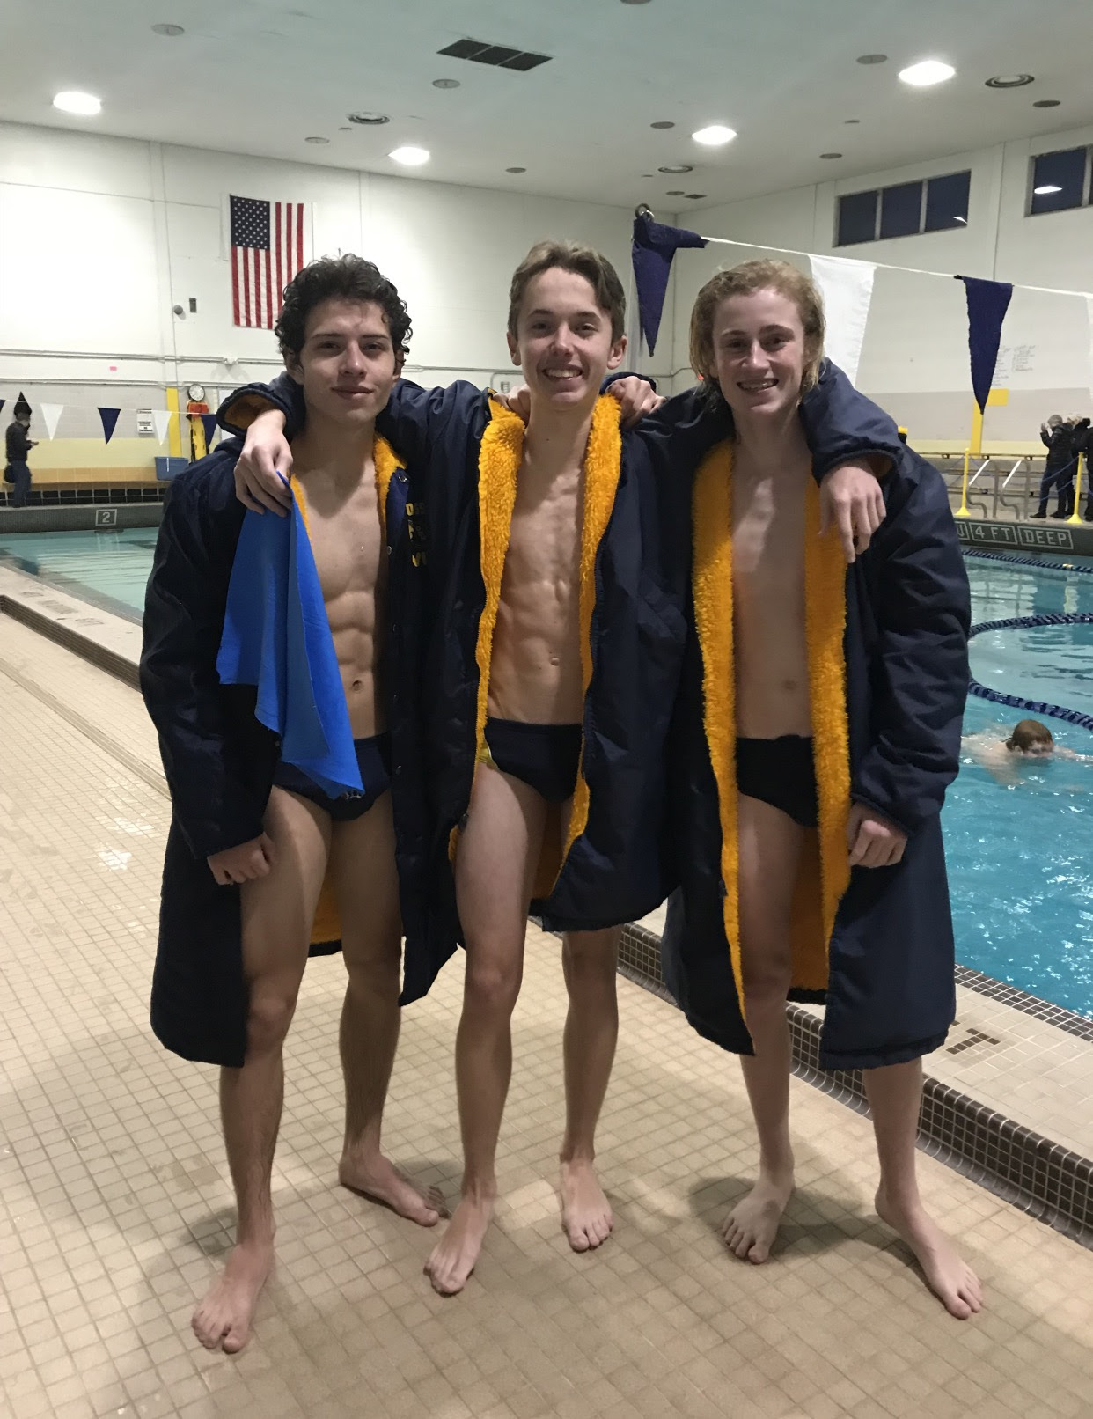
Owosso lost a tight contest against the visiting Holly Bronchos. Owosso fell to 3-2 but the highlight of the night was Owosso divers Mitchell Fisher, Ross Raatz and Brandon Steinley all qualifying for the MHSAA Dive Regionals by sweeping the diving event 1-2-3. Fisher totaled a 226.65, Steinley a 179.4 and Raatz a 159.1.
Owosso started out the night going 1-2 in the 200 medley relay with the team of Brendan Gute, Mitchell Fisher, Dan Hood and Ross Raatz taking 1st in 2:08.91 and the team of Nathan Gute, Jordan Sowash, Parker Omer and Brandon Steinley taking 2nd in 2:17.99.
Dan Hood then took 2nd in the 200 Freestyle in 2:06. Brendan Gute took 1st in the 200 IM with a time of 2:39.57 and Jordan Sowash took 3rd in 2:49.84. In the 100 Butterfly Parker Omer took 2nd in 1:15.83. In the 500 Freestyle Dan Hood and Jordan Sowash went 1-2 with times of 5:37.86 & 6:49.29. In the 100 Backstroke Brendan Gute took 2nd in 1:15.84 and in the 100 Breaststroke Mitchell Fisher took 2nd in 1:27.94. Owosso's 400 Freestyle Relay team of Dan Hood, Ross Raatz, Garrett Hoag and Brendan Gute took 2nd in 4:06.14.

