BRANDON HIGH SCHOOL
GIRLS VARSITY BASKETBALL
Brandon High School Girls Varsity Basketball beat Clio High School 59-51
Friday, February 3, 2023
5:30 PM
Brandon High School |  | Clio High School

HOME | AWAY
59 | 51

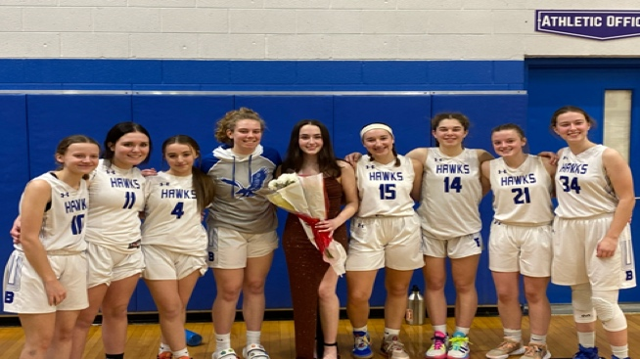
The Brandon varsity girls basketball team won their second straight game Friday night, defeating the Clio Mustangs by the final score of 59-51. The Hawks started the game on a rampage as their pressure defense caused turnover after turnover. Brandon was able to turn these turnovers into quick points, blitzing Clio with 32 first half points that included 7 made three's. Riley Abney capped a phenomenal week with 29 points, 4 rebounds and 5 steals, while Jaden Williamson had a tremendous game with 13 points and 10 rebounds. Lily Harvey notched 5 points and 8 rebounds, while Jada Brady had 6 points and 6 rebounds, and Abby Muehlheim added 6 points and 3 assists.
 | 1 | 2 | 3 | 4

Brandon High School | 16 | 16 | 10 | 17

 | 1 | 2 | 3 | 4

Clio High School | 7 | 10 | 16 | 18

