BRANDON HIGH SCHOOL
GIRLS VARSITY BASKETBALL
Brandon High School Girls Varsity Basketball beat Corunna High School 39-30
Friday, February 17, 2023
5:30 PM
Brandon High School |  | Corunna High School

AWAY | HOME
39 | 30

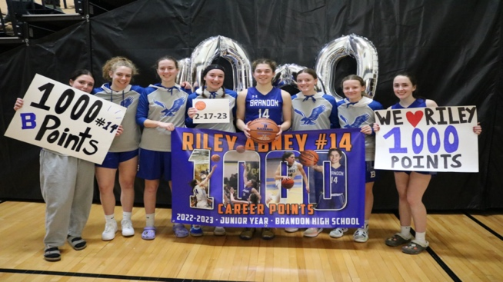
The Brandon varsity girls' basketball team hit the road Friday night for a game at conference rival Corunna. The Lady Blackhawks got off to a fast start jumping out to a 12-2 lead after a quarter of play and then held on in a low scoring affair to get the win 39-30. Riley Abney paced Brandon with 29 points, 3 rebounds, and 4 steals. Abney, who came into the game 25 points shy of 1,000 for her career, reached the milestone with a big three to extend the Blackhawk lead late in the third quarter. Jada Brady tallied 5 points, 3 rebounds, and 2 steals, while Jaden Williamson with 3 points and 6 rebounds, and Sophia Consiglio with 2 points and 4 rebounds played big minutes for the Hawks. Brandon heads into the final week of the regular season playing some of their best ball of the season and will look to keep things rolling as they head home for their next game Tuesday night.
 | 1 | 2 | 3 | 4

Brandon High School | 12 | 4 | 14 | 9

 | 1 | 2 | 3 | 4

Corunna High School | 2 | 6 | 11 | 11

