BRANDON HIGH SCHOOL
GIRLS VARSITY BASKETBALL
Brandon High School Girls Varsity Basketball beat Goodrich High School 56-43
Friday, February 10, 2023
5:30 PM
Brandon High School |  | Goodrich High School

AWAY | HOME
56 | 43

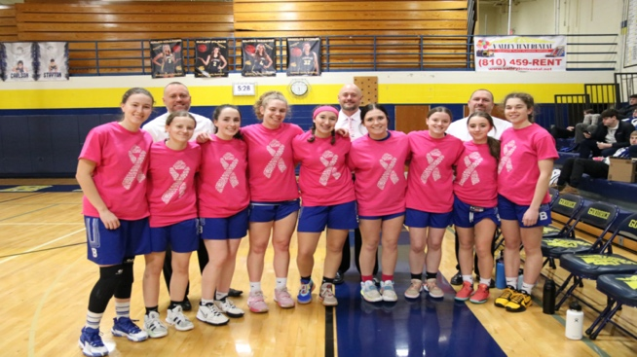
The Brandon Girls' Basketball team knew that they faced a tough task Friday night as they headed to Goodrich to take on a Martians squad ranked #8 in the state in Division 2. Heading into the game, Goodrich was 16-1 on the season and had defeated its opponents by an average of 35 points per game. The Lady Blackhawks however, would give the Martians all they could handle in one of their best performances of the season. The perserverance and heart that has led this team to tremendous improvement this season was on full display as the Hawks stood toe to toe with Goodrich throughout the game falling just short of pulling off the upset, falling by the final score of 56-43. Riley Abney fought through illness to provide her usual stellar stat line with 30 points, 5 rebounds, 2 assists, and 2 steals. Jada Brady added 5 points, 4 rebounds, and two assists, Abigail Muehleim battled in the post for 6 points, and 3 rebounds, and Lillian Harvey led the team with 7 rebounds on the night.
 | 1 | 2 | 3 | 4

Brandon High School | 7 | 11 | 15 | 10

 | 1 | 2 | 3 | 4

Goodrich High School | 16 | 13 | 18 | 9

