BRANDON HIGH SCHOOL
GIRLS VARSITY SWIMMING
Brandon High School Girls Varsity Swimming beat Holly High School 99-82
Thursday, October 7, 2021
6:00 PM
Brandon High School |  | Holly High School

HOME | AWAY
99 | 82

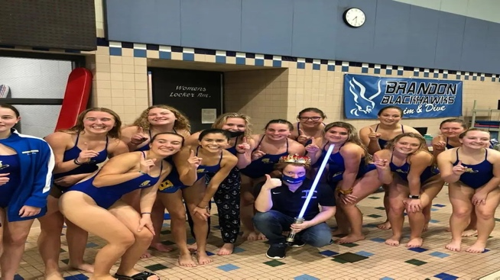
Three years ago a crown was delivered to the winner of Holly vs Brandon-Goodrich Girls Swimming. On October 7th, that crown changed possession. It started with the 200 medley Relay the Warhawks had won that race at the Genesee County meet the week before, but Holly had been hot on their heels. The Warhawks A relay (Misenar, Shall, Jaworowski, Jordan) won by four seconds, but their B relay (Pethick, Westra, Toombs, Polasek) narrowly missed 3rd place by .94 seconds. The 200 Freestyle was up next, the entry times were within one second or less of each other. Luz Medina, Andie Stewart, and Grace Hylton all stepped up to win second, third, and fourth for a big sweep of points. The 200 IM had the Bronchos outnumbering the Warhawks, but a big win by Helene Jaworowski and a new best time by Lila Buchler kept the score close. The 50 Freestyle proved to be an exciting burst of speed where the difference between first and fourth was .71 seconds, Emma Shall won second and Layla Jordan broke the 30s barrier to steal 4th from the Bronchos. Going into diving the score was Holly 32 / Brandon-Goodrich 30.
Both Warhawk Divers (Macy Polasek & Layal Jordan) took to the sky with grace getting second and third against some equally talented competition. The Bronchos responded by sweeping the 100 Fly, but Savannah Toombs held strong to get fourth in the event. Maddie Misenar then led a charge in the 100 Free, winning first by 4 seconds as her teammates (Luz Medina & Anderson Stewart) closed the gap with some much needed fourth and fifth place points. In the distance event of the 500 Freestyle the Warhawks came away with 11 points where Helene Jaworowski and Grace Hylton once again won first and second with Lila Buchler getting 5th. Going into the 200 Free Relay the score was tied at 61.
In the 200 Free Relay the Warhawks A relay (Jordan, Stewart, Shall, Misenar) fought to get another first place finish but ran out of pool to catch up. However, the B relay (Medina, Polasek, Pethick, Hylton) for the Hawks stepped up to win third and keep the Hawks in the game. The 100 Backstroke is where the meet started to turn in the Hawks' favor with Maddie Misenar getting first, Savannah Toombs narrowly out-touching her opponent to get second, and Brooklyn Pethick getting 4th. In the Breaststroke, Emma Shall and Anna Westra continued their 1-2 punch for another set of big points for the Hawks. It all culminated in the 400 Freestyle Relay where the A-Relay of Medina, Hylton, Stewart, and Jaworowski won the event and the B relay of Buchler, Toombs, Pethick, and Westra won third. It was a meet decided by small victories and much as the big first place races. A true team effort with everyone playing their role exactly as they needed to. Brandon-Goodrich finished the night with 13 Personal Bests, 8 First Place wins, 6 second place wins, and 4 third place wins.

