GOODRICH HIGH SCHOOL
BOYS VARSITY SOCCER
Goodrich High School Boys Varsity Soccer beat Fenton High School 1-0
Monday, October 3, 2022
6:15 PM
Goodrich High School |  | Fenton High School

AWAY | HOME
1 | 0

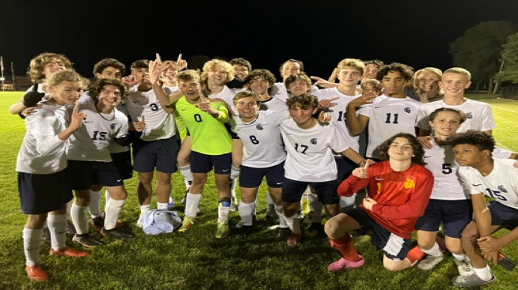
Fall temps bring on the feeling of championships, and the weather set the tone for just that! The single goal of the contest decided the outcome of the Metro League Champs at Fenton in favor of the visiting Martians of Goodrich.

Goodrich goalkeeper, Kyle Elges, put his skill set on display and continued to tally legitamate saves throughout the contest and keep a clean sheet. Recognizing his work ethic, and his contirbutions to the team win, Kyle was voted by his peers as the Player of the Game. He is pictured, in the center, surrounded by his teammates as they celebrated the Metro League championship.

The lone goal of the contest was scored by Caeden Rossell and was assisted on a hustle play by Jaden Urogdy.

The Martians carry the points lead in the Flint Metro League as they head into the final league contest Wednesday at home vs Clio.

