Goodrich High School Boys Varsity Soccer beat Linden High School 1-0
Wednesday, August 31, 2022
6:15 PM
Goodrich High School |  | Linden High School

AWAY | HOME
1 | 0

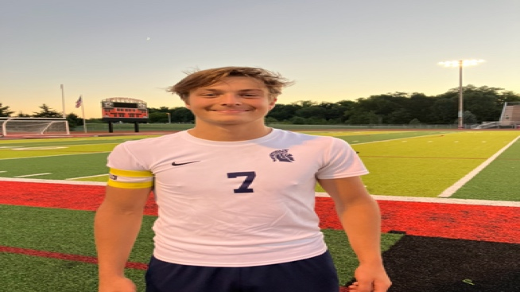
Great contest tonight at Linden! John Pringle with the lone goal of the contest assisted by your Player of the game, Caeden Rossell (pictured)! Kyle Elges with his first shutout in net! Well played all around!!
Posted by Evan Huizenga coachevanh@gmail.com

