HOLLY HIGH SCHOOL
GIRLS VARSITY TRACK & FIELD
Holly High School Girls Varsity Track & Field finishes 1st place at Meet @ Owosso High School
Wednesday, May 8, 2019
4:00 PM
Place |  | Points

1 | 0

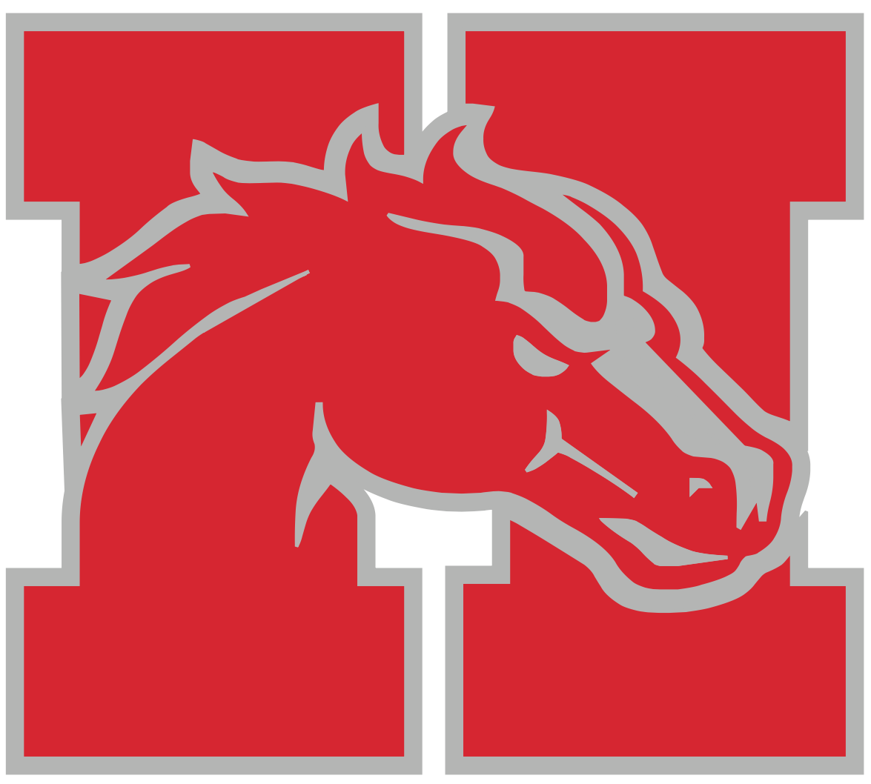
The Holly Girls Track and Field Team close the regular season on a strong note. The team moves to 6-2 in the league. Top three finishers include:
100 meter dash: Gabrielle St. Andre, 1st/2nd Place
Alyssa Johnson, 2nd Place
200 meter dash: Gabrielle St. Andre, 1st/2nd Place
Alyssa Johnson, 2nd Place
Gillian Cohoon, 3rd Place
400 meter dash: Gabrielle St. Andre, 1st/2nd Place
Jaime Drouin, 2nd/3rd Place
800 meter run: Andrea Ruiz, 1st/2nd Place
Monica Ruiz, 2nd/3rd Place
1600 meter run: Andrea Ruiz, 2nd Place
Jaime Drouin, 3rd Place
3200 meter run: Andrea Ruiz, 1st/3rd Place
100 hurdles: Annah Charles, 1st Place
Aniya Semer, 2nd/3rd Place
300 hurdles: Annah Charles, 1st Place
Jaryn Kivari, 3rd Place
4x100 Relay: Alyssa Johnson, Aniya Semer, Annah Charles, Faith Lee, 1st Place
4x200 Relay: Alyssa Johnson, Aniya Semer, Annah Charles, Faith Lee, 1st Place
Shot Put: Abigail Johnston, 1st/2nd Place
Marissa Johnston, 2nd/3rd Place
Discus: Abigail Johnston, 2nd Place
High Jump: Aniya Semer, 1st Place
Jolie Monty, 2nd/3rd Place
Pole Vault: Josephine Tschirhart, 2nd/3rd Place
All results can be found at:
https://www.athletic.net/TrackAndField/MeetResults.aspx?Meet=352295&show=all
School |  | Place |  | Points

Holly High School |  | 1 |  | 0

