HOLLY HIGH SCHOOL
GIRLS VARSITY TRACK & FIELD
Holly High School Girls Varsity Track & Field finishes 1st place at Meet @ Holly High School
Wednesday, April 17, 2019
4:00 PM
Place |  | Points

1 | 0

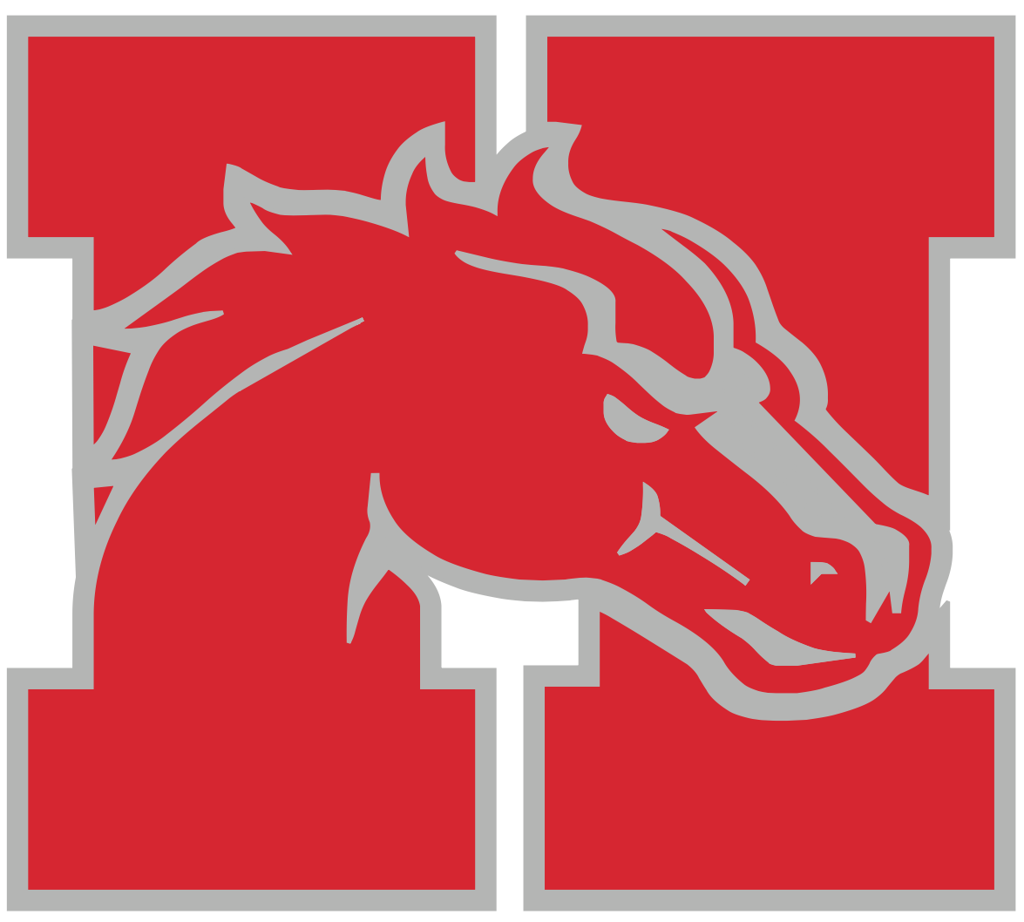
The Holly Girls Track and Field team performed well to start the season 2-0. Every girl on the team contributed and competed well in the meet against Brandon and Linden. Top three finishers included:
100 meter dash: Gabrielle St. Andre 1st place
Alyssa Johnson 3rd Place
200 meter dash: Gabrielle St. Andre 1st Place
Alyssa Johnson 3rd Place
400 meter dash: Monica Ruiz 2nd Place
800 meter run: Jaime Drouin 1st Place
Ally Blodgett 2nd/3rd Place
1600 meter run: Andrea Ruiz 1st Place
3200 meter run: Andrea Ruiz 1st Place
Jaime Drouin 2nd/3rd Place
Monica Ruiz 3rd Place
100 Hurdles: Annah Charles 1st Place
Aniya Semer 3rd Place
4x100 Relay: Alyssa Johnson, Aniya Semer, Jolie Monty, Gabrielle St. Andre 1st Place
4x200 Relay: Annah Charles, Josephine Tschirhart, Jolie Monty, Gabrielle St. Andre 1st Place
4x400 Relay: Ally Blodgett, Monica Ruiz, Andrea Ruiz, Jaime Drouin 1st Place
4x800 Relay: Ally Blodgett, Monica Ruiz, Andrea Ruiz, Jaime Drouin 1st Place
Shot Put: Abigail Johnston 1st/3rd Place
Marissa Johnston 3rd Place
Discus: Abigail Johnston 1st Place
Rebecca Gierlach 3rd Place
High Jump: Aniya Semer 2nd Place
Jolie Monty 3rd Place
Pole Vault: Josephine Tschirhart 2nd Place
MiCayla Smith 3rd Place
Long Jump: Gillian Cohoon 2nd/3rd Place
All results can be found at:
https://www.athletic.net/TrackAndField/MeetResults.aspx?Meet=352285&show=all
School |  | Place |  | Points

Holly High School |  | 1 |  | 0

Brandon High School |  | 2 |  | 49

