HOLLY HIGH SCHOOL
GIRLS VARSITY TRACK & FIELD
Holly High School Girls Varsity Track & Field finishes 1st place at Meet @ Clio High School
Tuesday, April 23, 2019
4:00 PM
Place |  | Points

1 | 0

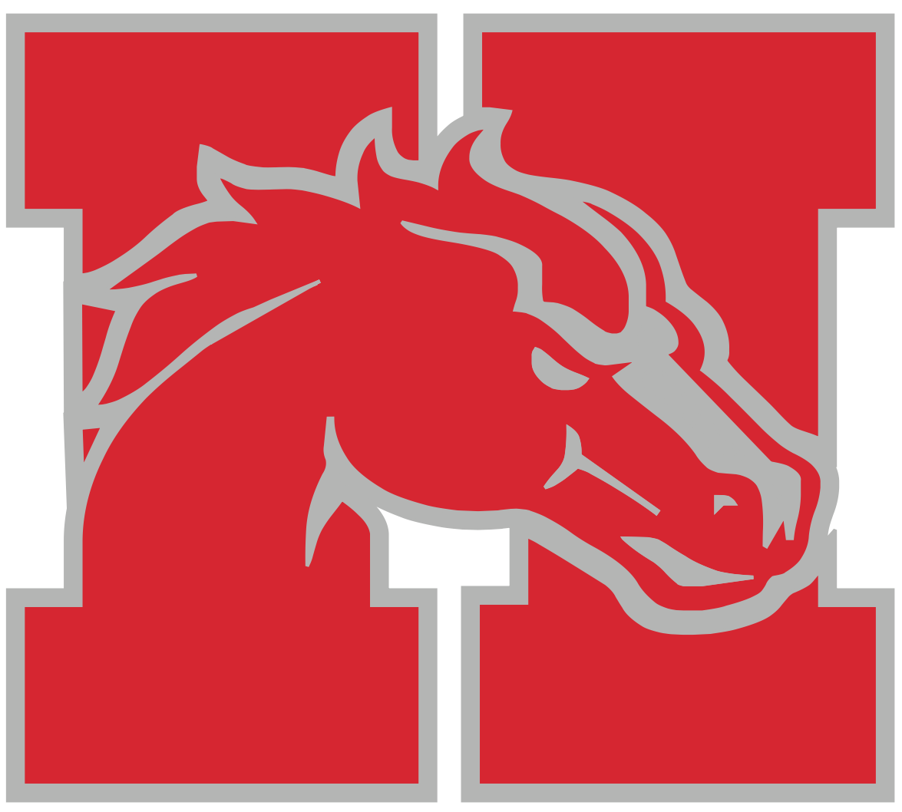
The Holly Girls Track and Field Team stayed on top of the FML standings moving to 4-0 with wins over Swartz Creek and Clio Tuesday night. Every girl contributed to the two victories, top three finishers include:
100 meter dash: Gabrielle St. Andre, 1st Place
Aniya Semer, 2nd Place
200 meter dash: Gabrielle St. Andre, 1st Place
400 meter dash: Jaime Drouin, 1st Place
Ally Blodgett, 2nd Place
800 meter run: Andrea Ruiz, 1st Place
Monica Ruiz, 2nd Place
1600 meter run: Andrea Ruiz, 1st Place
3200 meter run: Andrea Ruiz, 1st Place
100 Hurdles: Annah Charles, 1st/2nd Place
300 Hurdles: Annah Charles, 1st/2nd Place
Jaryn Kivari, 3rd Place
4x1 Relay: Annah Charles, Josephine Tschirhart, Sydnie Meszler, Brooke Wells, 1st Place
4x2 Relay: Jaime Drouin, Monica Ruiz, Aniya Semer, Gabrielle St. Andre, 1st Place
4x4 Relay: Gabrielle St. Andre, Monica Ruiz, Ally Blodgett, Jaime Drouin, 1st Place
4x8 Relay: Ally Blodgett, Monica Ruiz, Andrea Ruiz, Jaime Drouin, 1st Place
Shot Put: Abigail Johnston, 2nd Place
Rebecca Gierlach, 3rd Place
Discus: Abigail Johnston, 1st Place
Rebecca Gierlach, 3rd Place
High Jump: Aniya Semer, 1st Place
Jolie Monty, 2nd Place
Pole Vault: Josephine Tschirhart, 1st Place Tie
MiCayla Smith, 1st Place Tie
Long Jump: Gillian Cohoon, 3rd Place
All Results Can Be Found At:
https://www.athletic.net/TrackAndField/MeetResults.aspx?Meet=360705&show=all
School |  | Place |  | Points

Holly High School |  | 1 |  | 0

Clio High School |  | 2 |  | 42

