HOLLY HIGH SCHOOL
GIRLS VARSITY SWIMMING
Holly Bronchos Defeat Kearsley Lake Fenton
Tuesday, October 17, 2023
6:00 PM
Holly High School |  | Kearsley High School

HOME | AWAY
109 | 70

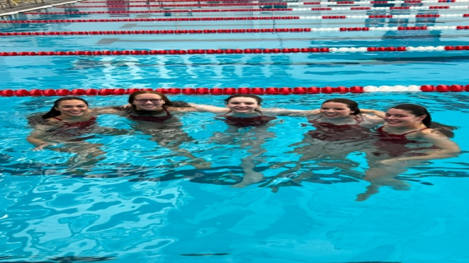
Tuesday night was senior night for the Holly Bronchos swim and dive team. With four seniors and one foreign exchange student finishing up their last home meet in the Holly pool, the Bronchos claimed victory. Throughout the evening, there were 19 top three finishes for the Bronchos and several best times overall. Though there were tears, the emotions of the evening contributed to a wonderful night of celebration and a near send off.
Holly started off the evening with class relays in the 200 medley, finishing in predicted order; seniors were first, juniors second, sophomores third, and freshman fourth. This fun level of in-team competition brought the team a new level of excitement. From there, the Bronchos shared in enthusiasm, support, and pride. Both divers, Riley Hummel and Percy Kline earned their regional qualifications after placing first and second.
Overall it was a successful meet for the Bronchos and a great show of sportsmanship from all athletes. With just two weeks left in season, the Bronchos have a good amount of work to put in before the end of season league meet. Next week is the last dual meet at Fenton High School against the Tigers.

