HOLLY HIGH SCHOOL
BOYS VARSITY GOLF
Holly High School Boys Varsity Golf beat Owosso High School 194-203
Monday, April 22, 2019
3:00 PM
Holly High School |  | Owosso High School

AWAY | HOME
194 | 203

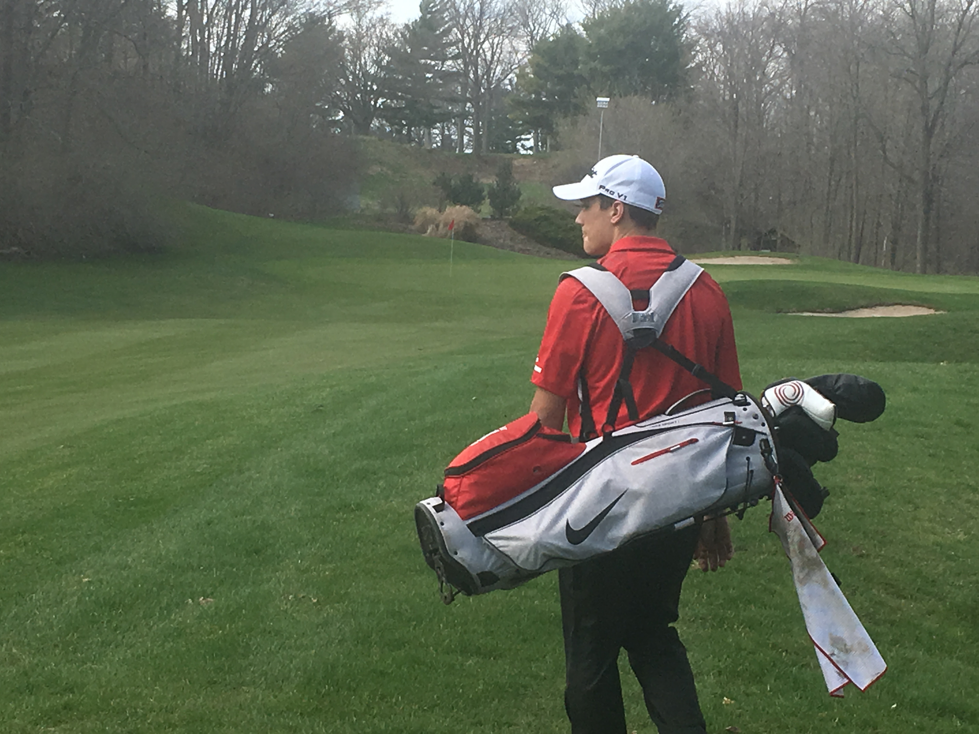
Finally some nice weather for Holly's first dual of the season. Holly defeated Owosso by a score of 194 to 203. Holly was lead by Junior Danny Mathews shooting a 45 and sophomore Sammy Fleischer carding a 47. Holly will face Linden on Tuesday at Heather highlands.

