KEARSLEY HIGH SCHOOL
GIRLS VARSITY BOWLING
Kearsley High School Girls Varsity Bowling beat Brandon High School 30-0
Wednesday, January 17, 2018
5:30 PM
Kearsley High School |  | Brandon High School

AWAY | HOME
30 | 0

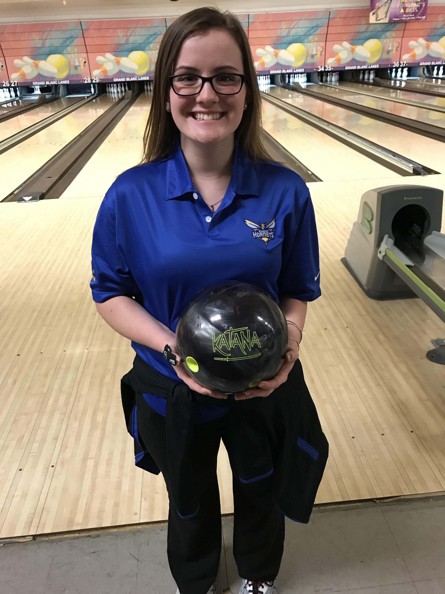
The Kearsley Varsity Girls had a Metro Conference Match against Brandon on Wednesday, January 17th at Grand Blanc Lanes. The Lady Hornets started the match with Baker games of 203 & 205 to Brandon's 148 and 124 as the Hornets took a 10-0 lead into the individual games. In the first individual game the Lady Hornets bowled an 1141 actual (The highest team game in the state so far this season for girls). Brandon had an 802 first game. In the second team game the Hornets had a 1007 game to Brandon's 725. The total final pinfall was Kearsley 2556 to Brandon's 1799 and the final score was 30-0. The 2 game series of 2148 that the Kearsley girls bowled is also the highest 2 game series in the state so far this season. Scores for Kearsley were: Barbara Hawes 248 & 234, Karlee Griffin 197, Emma Boychuk 221, Alexis Roof 225 & 190, Imari Blond 250 & 193, Allison Robbins 188 and Mary Wheeler 202. The Hornets are now 8-0 on the season and leading the Metro Conference. The next Metro Conference match is Saturday, January 20th at Cherry Hill Lanes in Clarkston against Owosso who is 7-1 on the season. The match will be for first place in the Metro Conference and the match begins at 9:30am.

