KEARSLEY HIGH SCHOOL
GIRLS VARSITY BOWLING
Kearsley High School Girls Varsity Bowling beat Clio High School 29-1
Wednesday, February 6, 2019
6:00 PM
Kearsley High School |  | Clio High School

HOME | AWAY
29 | 1

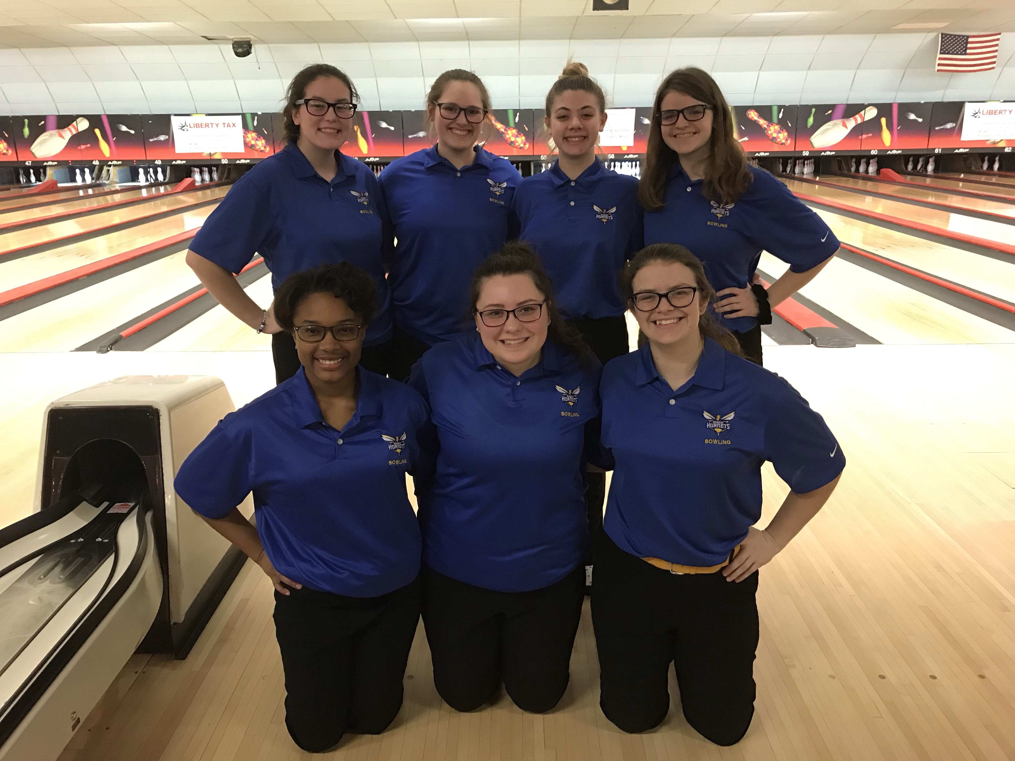
The Kearsley Varsity girls traveled to Grand Blanc Lanes on Monday, February 11th for the final Metro Conference match of the season against Clio. The match was a make up for the match that was canceled last week because of the weather. The Kearsley girls started the match with Baker games of 164 and 202 to Clio's 150 and 113 and with a 10-0 lead going into the individual games the Lady Hornets never looked back. The first team game Kearsley won 8 out of 9 points and won the game 902 to 717 and then Kearsley won the last game 1016 to 755. The total final pinfall was Kearsley 2284 to Clio 1735 and the final score was Kearsley 29 to Clio 1. The win finishes off the 10th straight undefeated season for the Kearsley girls bowling program and brings their winning streak to 120 matches as they finish the Metro Conference season at 16-0. Scores for the Kearsley girls were Samantha Timm 168, Allison Eible 202 & 176, Megan Timm 179 & 206, Imari Blond 146, Alexis Roof 207 & 246, Allison Robbins 198 and Emilea Sturk 190. The next competition for the Lady Hornets is the Metro Conference Singles Championship on Saturday, February 16th at Capitol Bowl in Owosso at 1:30pm.

