KEARSLEY HIGH SCHOOL
GIRLS VARSITY BOWLING
Kearsley High School Girls Varsity Bowling beat Fenton High School 25-5
Saturday, February 9, 2019
9:30 AM
Kearsley High School |  | Fenton High School

HOME | AWAY
25 | 5

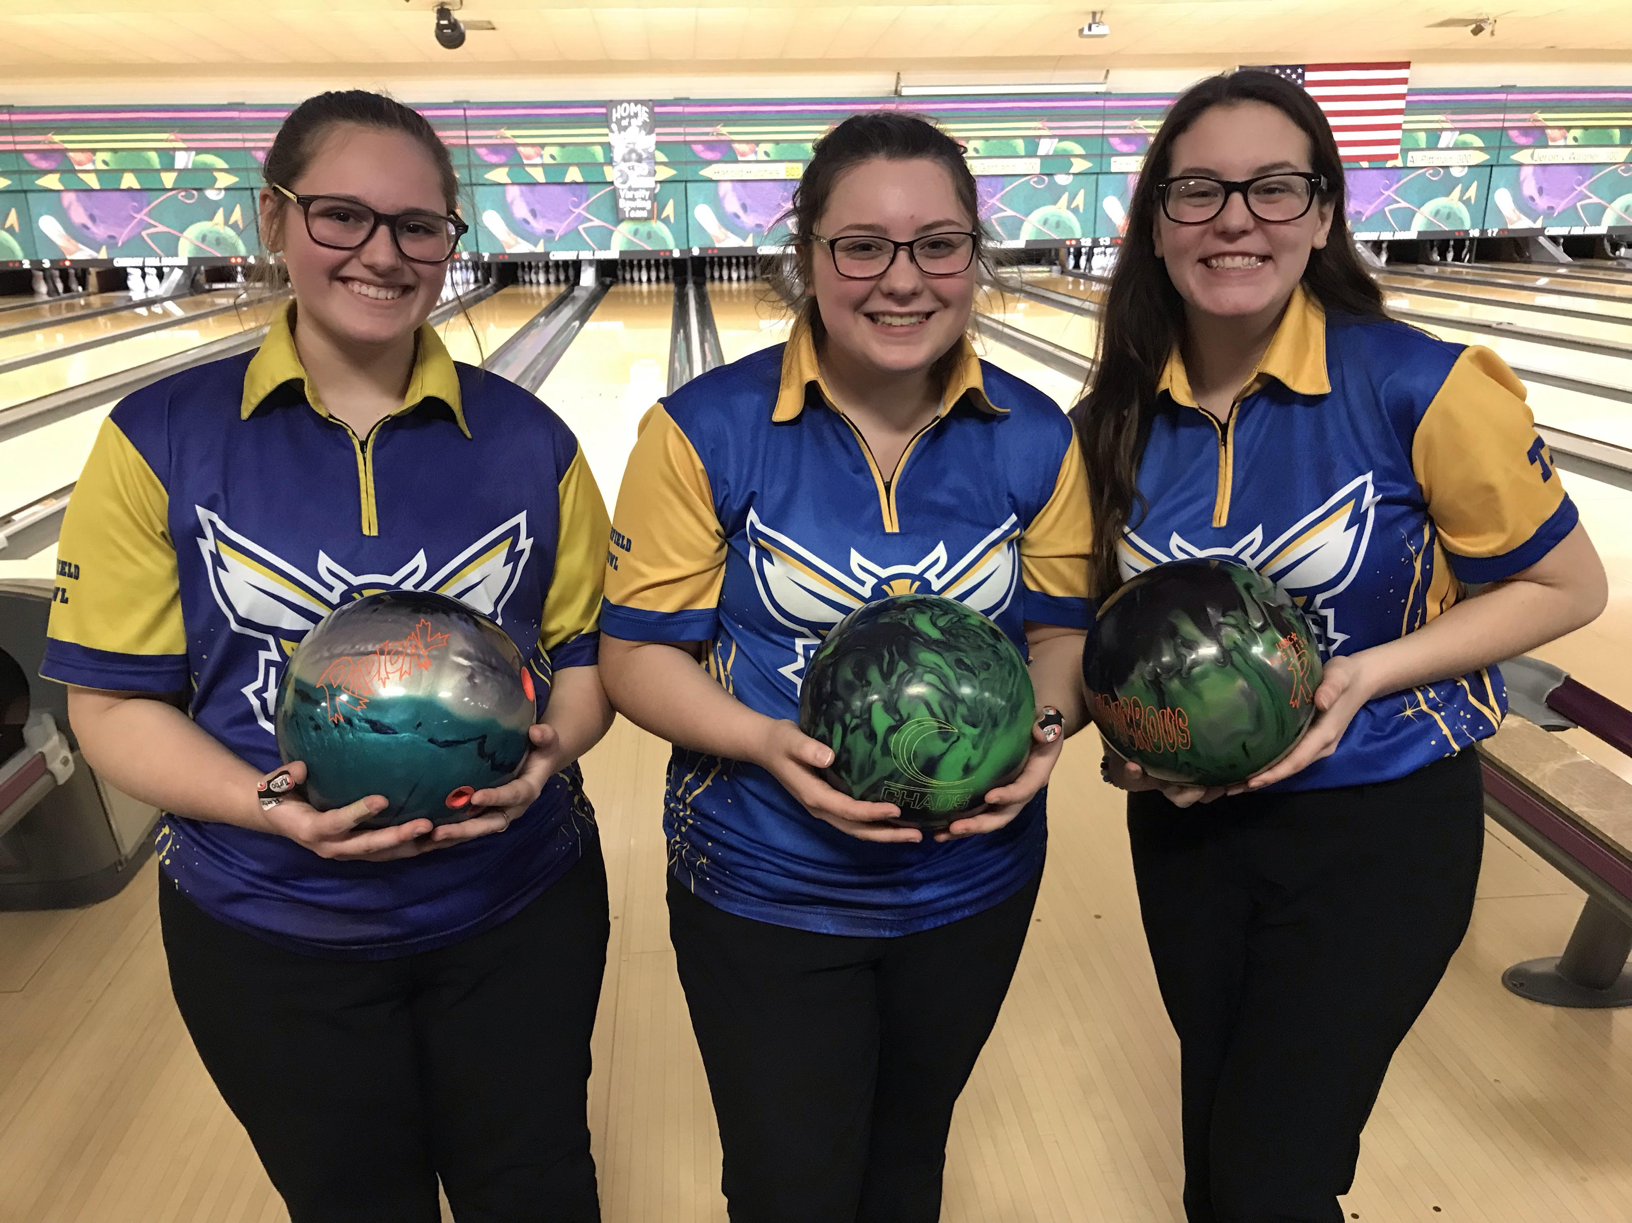
The Kearsley varsity girls traveled to Cherry Hill Lanes in Clarkston for a Metro Conference match against Fenton on Saturday, February 9th.The match started slowly for the Kearsley girls as they struggled for the 2nd week in a row in the Baker games but pulled out a 6-4 lead going into the individual games as the Lady Hornets had Baker games of 146 & 118 to Fenton's 109 & 147. The Kearsley girls won the total pins in Baker's 264 to 256 to take the lead in the match. In the first individual game the Lady Hornets got back to form as they won 8 of 9 points with a 973 to 720 victory and the last individual game they won all 9 points with a 1012 to 691 victory. The total final pinfall for the match was Kearsley 2249 to Fenton 1667 and the final score was 25-5. Scores for Kearsley were Samantha Timm 205 & 173, Allison Eible 206 & 200, Megan Timm 193, Alexis Roof 194 & 238, Imari Blond 175, Allison Robbins 190 and Emilea Sturk 211. The Lady Hornets are now 15-0 and have clinched the Flint Metro Conference title all by themselves for the 10th consecutive year. They also have a 119 match winning streak spanning that 10 years. The girls will travel to Bay City and Monitor lanes on Sunday, February 10th for the S & R Singles Tournament and then will wrap up the regular season in the Metro Conference on Monday, February 11th as they try to close out the season undefeated when they take on Clio at Grand Blanc Lanes at 6pm.

