KEARSLEY HIGH SCHOOL
BOYS VARSITY BOWLING
Kearsley High School Boys Varsity Bowling beat Flushing High School 16-14
Wednesday, December 12, 2018
6:30 PM
Kearsley High School |  | Flushing High School

HOME | AWAY
16 | 14

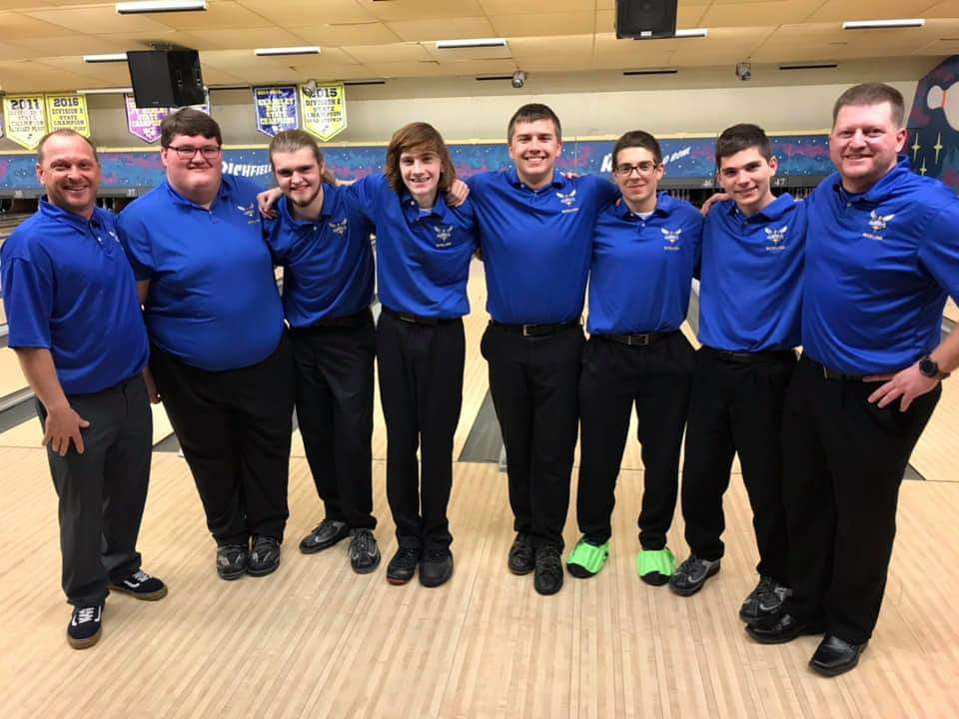
Wednesday night the Kearsley Hornets took on the Flushing Raiders at Richfield Lanes. The Hornets started slow losing the first baker game 179-186 and the second game 209-258 with a total deficit of 388-444 and 10 points to 0. During the first game of the team game portion of the match Senior Kyle Langworthy led the way with a big game of 278. Ethan Burke followed with a 268 Gage Slagor 214 and winning total 1081-976 making the points Hornets 7 Raiders 12. The last game was more of the same Kearsley showed some grit and fight in them Ethan Burke paced the Hornets with a 211 giving him a 479 total. Kyle Lagworthy followed up with a 204 and a 482 total. Freshman Gage Slagor proved why he is in his varsity position by throwing a double in the tenth frame to win his point and guarantee the match win. Kearsley won the second game 941-868 and overall totals 2410-2288. So far the Hornets are 4-0 and have won their first tournament of the year.

