KEARSLEY HIGH SCHOOL
GIRLS VARSITY BOWLING
Kearsley High School Girls Varsity Bowling beat Owosso High School 29.5-0.5
Saturday, January 12, 2019
1:00 PM
Kearsley High School |  | Owosso High School

AWAY | HOME
29.5 | 0.5

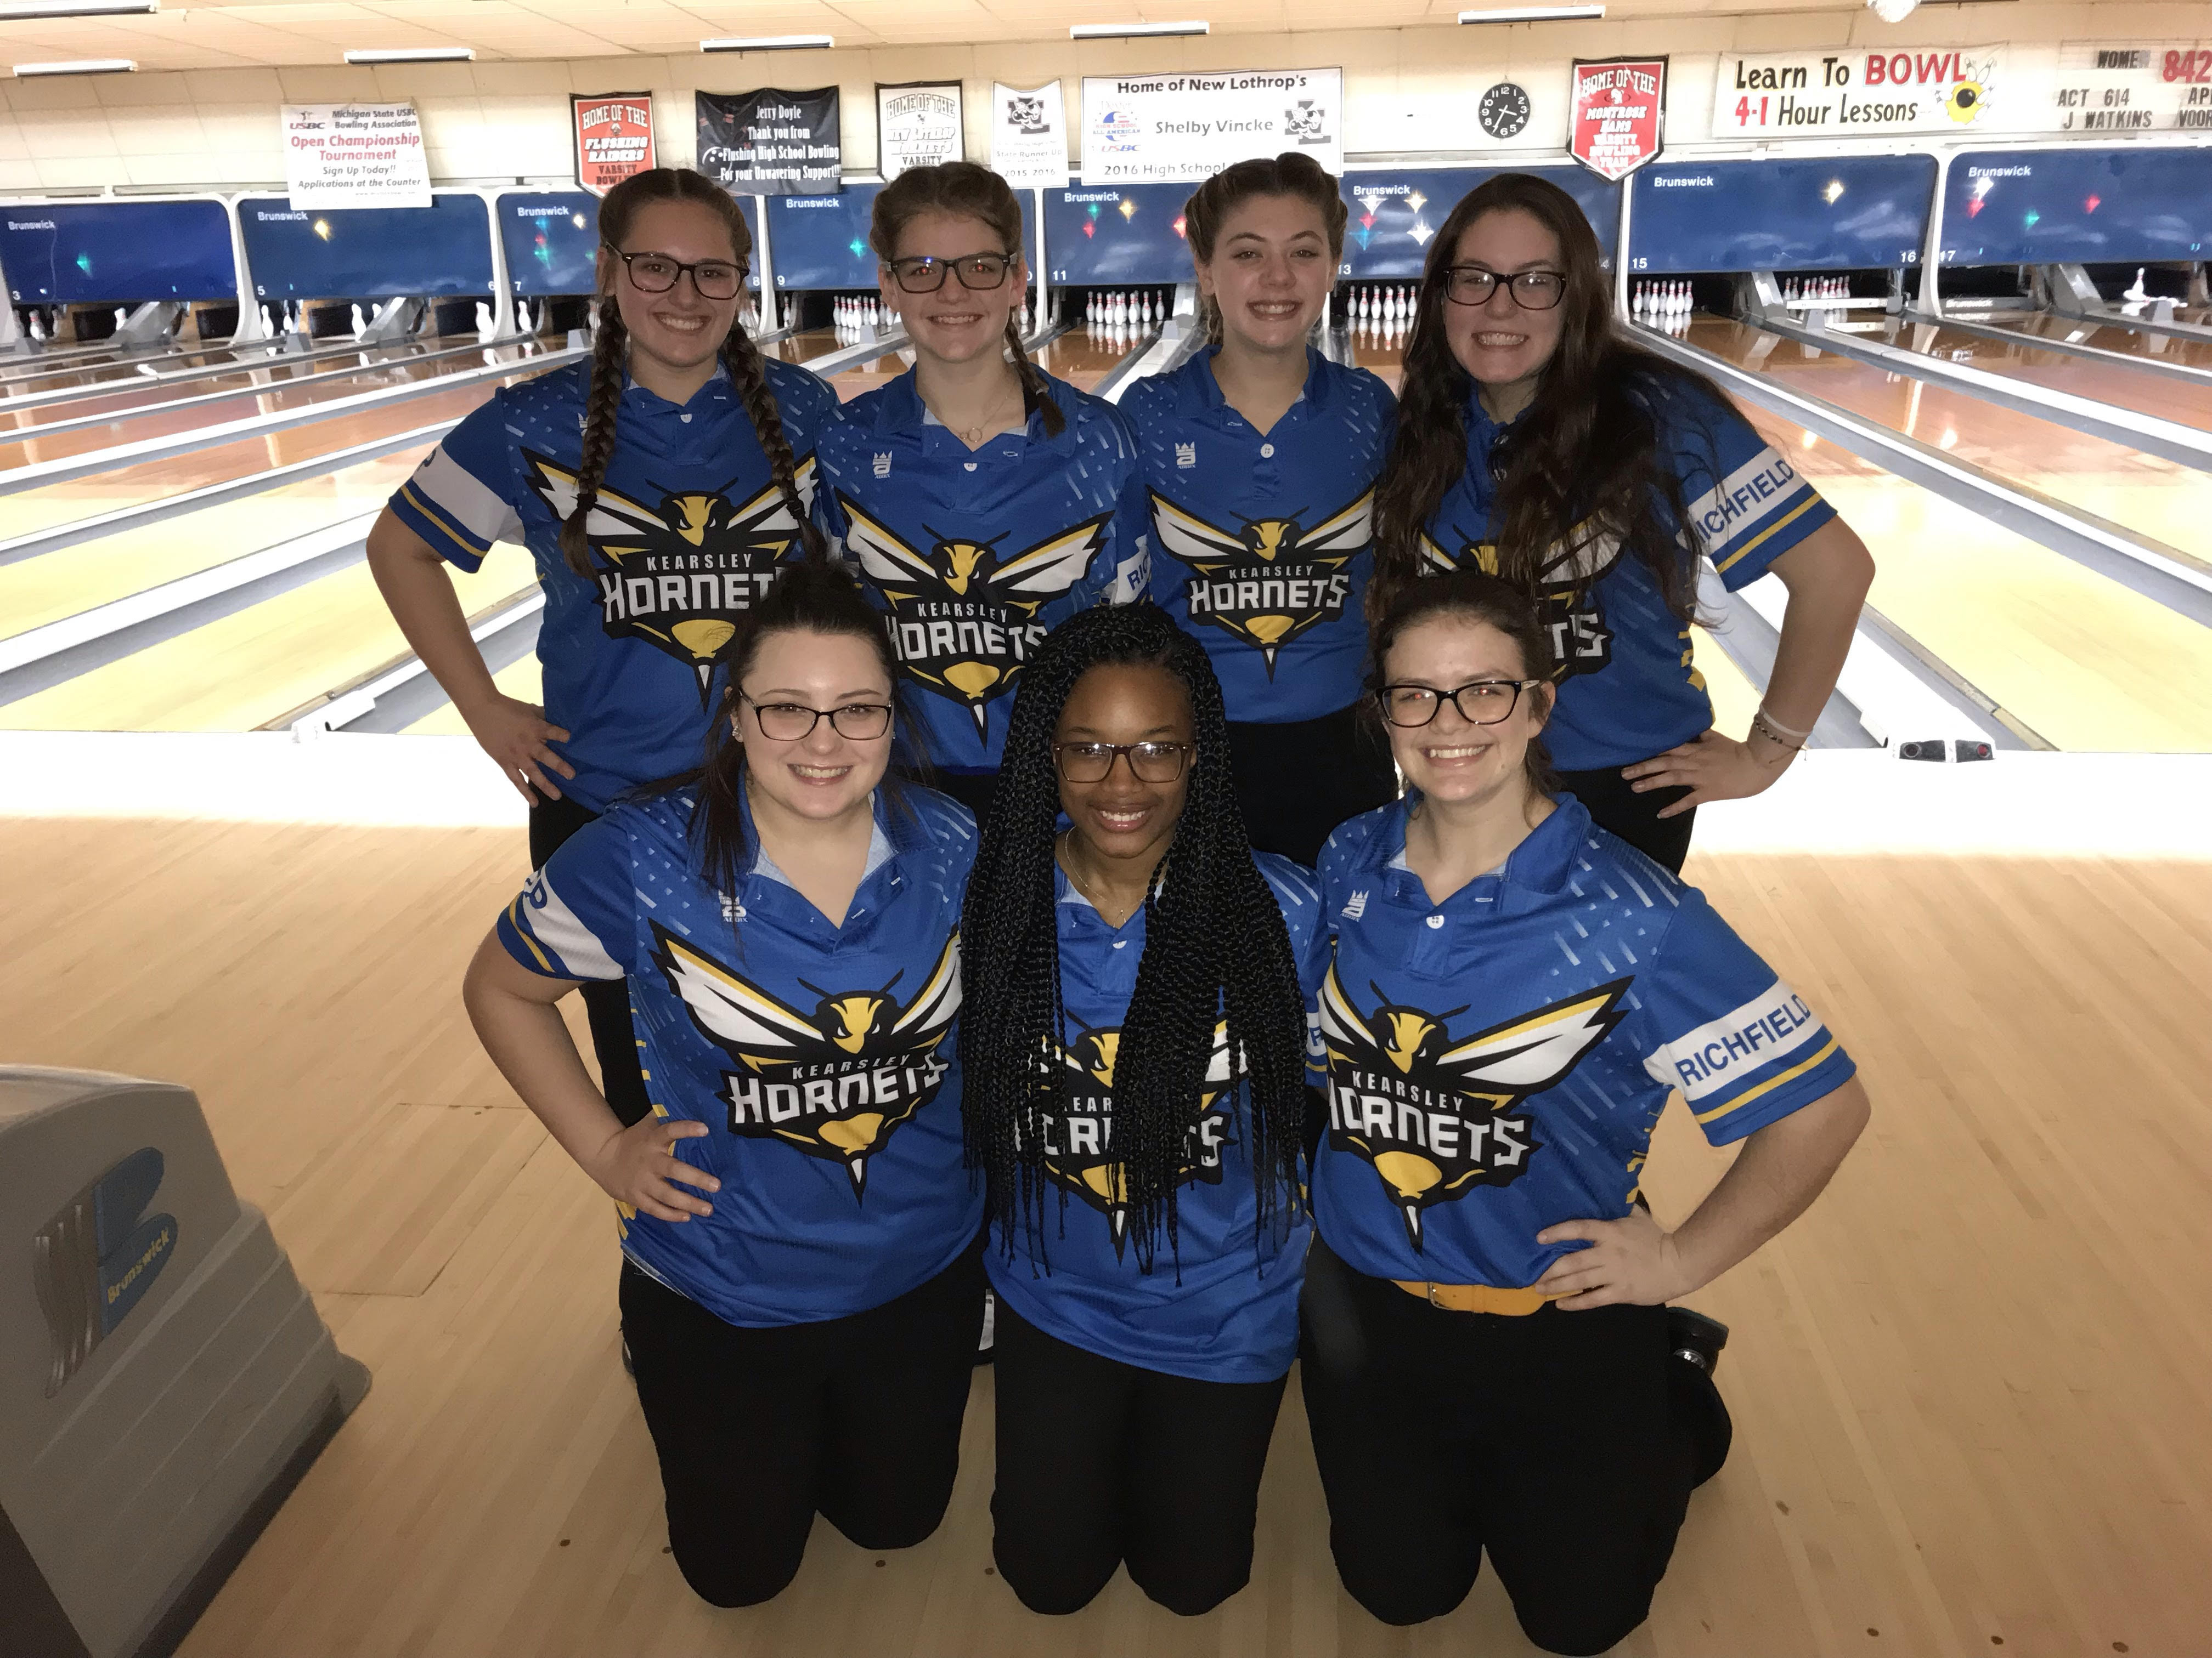
The Kearsley Varsity girls bowling team traveled to Colonial Lanes in Flushing for a Metro Conference match against Owosso on Saturday, January 12th. The Lady Hornets began the match with Baker games of 182 & 199 top Owosso's 150 and 160 and with a 10-0 lead heading into the individual games the Lady Hornets were looking good. In the first individual team game the Hornets had a 1006 game to Owosso's 775 and the last individual game the Lady Hornets had a 985 team game to Owosso's 617. The total final pinfall was Kearsley 2372 to Owosso 1702 and the final score was Kearsley 29.5 to Owosso .5.
Scores for the Kearsley girls were: Emilea Sturk 202 & 162, Allison Eible 195 & 240, Megan Timm 163, Alexis Roof 191, Imari Blond 255 & 200, Samantha Timm 225 and Allison Robbins 158. The Lady Hornets are 9-0 now in the Metro Conference and lead Flushing by 1 game with 7 games left.
The next competition for the Lady Hornets is Wednesday night, January 16th at 6pm at Grand Blanc Lanes as they bowl against Linden.

