KEARSLEY HIGH SCHOOL
GIRLS VARSITY BOWLING
Kearsley High School Girls Varsity Bowling beat Swartz Creek High School 26-4
Saturday, January 19, 2019
11:00 AM
Kearsley High School |  | Swartz Creek High School

AWAY | HOME
26 | 4

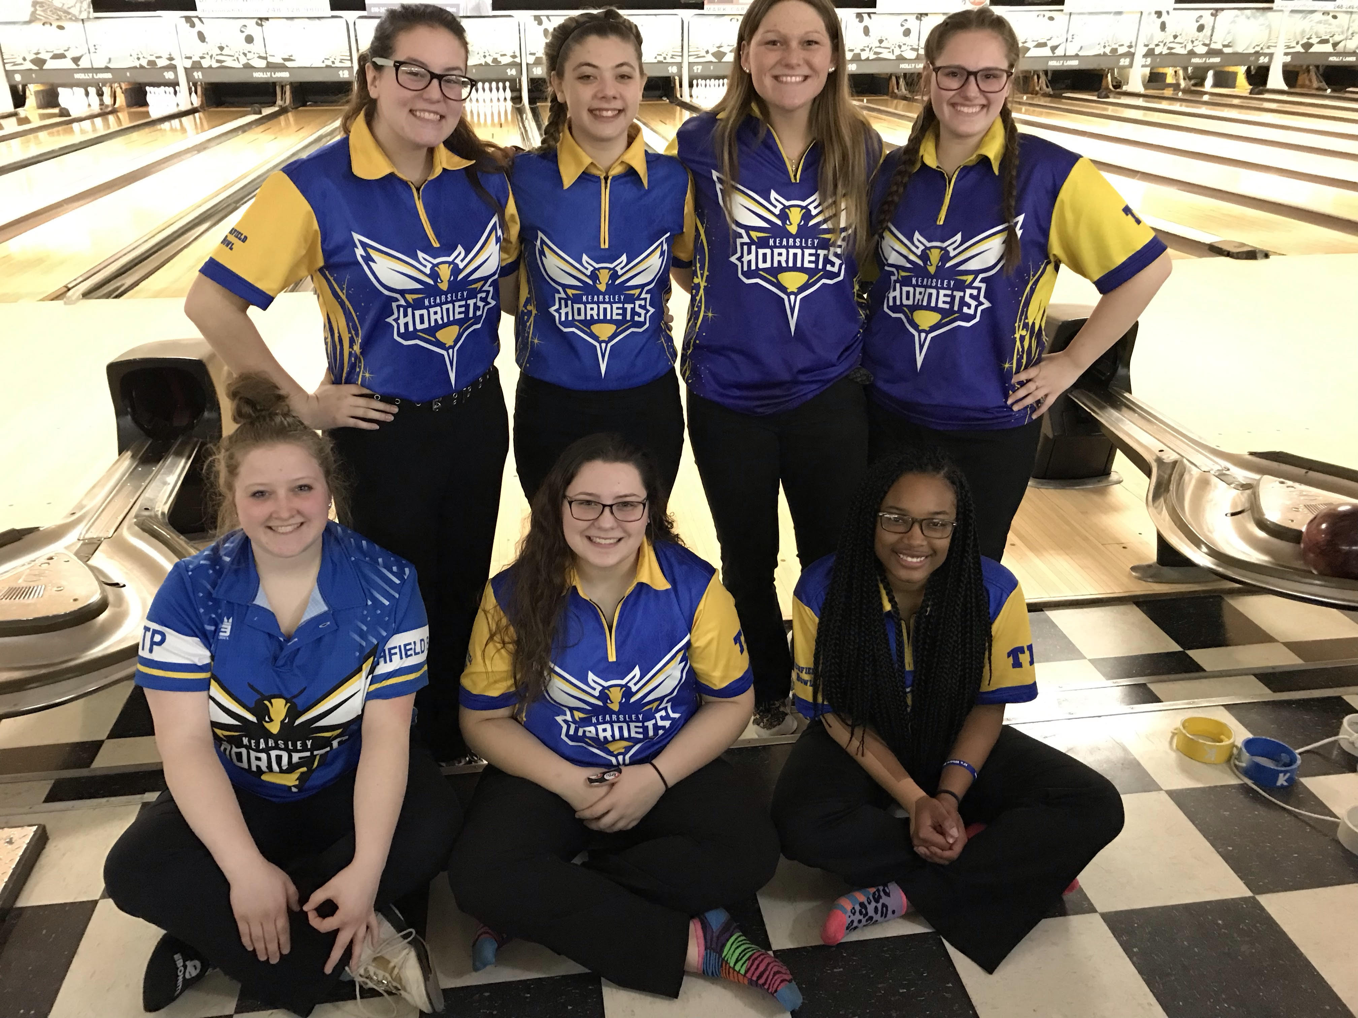
The Kearsley Varsity girls traveled to Holly Lanes in Holly for a Metro Conference match against Swartz Creek on Saturday, January 19th. The Lady Hornets began the match with Baker games of 164 & 190 to Swartz Creeks 144 and 189 games. The Lady Hornets 2 game Baker total of 354 to Swartz Creek's 333 gave the Hornets a 10-0 lead heading into the individual games. In the first individual game the Lady Hornets had their hands full the entire game but pulled out the win with a 1008 team total to Creek's 957 and the 2nd individual team game was just as close as the Lady Hornets won the last team game 950 to 898. The final total pinfall was Kearsley 2312 to Swartz Creek 2188 and the final score was Kearsley 26 and Swartz Creek 4. Scores for Kearsley were: Emilea Sturk 201, Allison Eible 205 & 213, Allison Robbins 172, Alexis Roof 222 and 204, Imari Blond 208 & 220, Hannah Simms 122 and Mary Wheeler 191. The Lady Hornets are now 11-0 on the season and still maintain a 1 game lead over the Flushing girls who are 10-1 on the season. The next competition for Kearsley is the Metro Conference Championship Tournament that will be held on Sunday, January 20th at Richfield Bowl, Kearsley is the host for this tournament and they have 43 teams from around the state coming to participate on Sunday.

